Chapter Certification Program

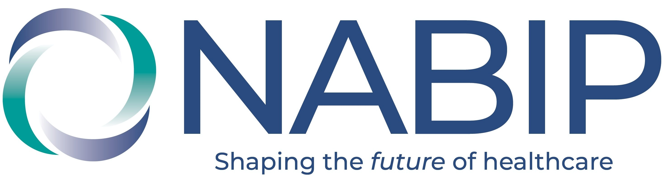

2024 Status Report for Florida (GOLD – 9)

*As of May 19, 2024*

|  |  |
| --- | --- |
| **CRITERIA** | **DOCUMENTATION** |
| **Leadership Positions:**  *Duplication is acceptable for up to two offices* | *SATISFIED* |
| President | *Angela Mlynarski, PAC- Y* |
| President-Elect | *Morgan Campbell, PAC- Y* |
| Secretary | *Tammy Cravotta, PAC- Y* |
| Treasurer | *Jennifer LaTour, PAC- N* |
| Membership & Retention Chair | *Rhett Robbins, PAC- Y* |
| Legislative Chair | *Corey Lilburn, PAC- Y* |
| Professional Development Chair | *Carolyn Taylor, PAC- N* |
| **Bylaws:** NABIP Name Change | *SATISFIED: Bylaws amended with NABIP* |
| **State PAC** | *SATISFIED: IRS Form 8871* |
| **Lobbyist** | *SATISFIED: Through December 31, 2024* |
| **Minimum number of membership events**  *State = 4 times/yr, Local = 8 times/yr* | NOT SATISFIED*:*   * *01/29-30/24 – Day on the Hill* |
| **Strategic Plan** (Must be a formal document, minutes are not acceptable.) | *SATISFIED* |
| **Budget** | *SATISFIED* |
| **Net membership increase** | *SATISFIED: 1% (02/23, 715 - 02/24, 720)* |
| **NABIP PAC contribution from above listed board members at Triple Crown Level ($10x12 or $150)** | NOT SATISFIED |
| **Directors & Officers Insurance** | *SATISFIED: Through 01/03/2025* |
| **NABIP Website Navigation Program at a membership** | NOT SATISFIED: No current information on file |
| **IRS Filing for Not-For-Profit Status** *(1st yr)* | *SATISFIED* |
| **IRS Annual Tax Filing** *(following yrs requirement)* | NOT SATISFIED: No current information on file *1* |
| **Communications**   * **To legislators** *(2 times a year)* * **To the media** *(2 times a year)* * **To the membership** *(6 times a year)* * **Promote NAHU’s LPRT, Triple Crown and certification programs** *(3 times a year)* | NOT SATISFIED: No current information on file |

**Silver Certification** requires chapters to satisfy six of the above14 criteria. **Gold Certification** requires that nine criteria be satisfied, and **Platinum Certification** requires that all 14 of the stated criteria be satisfied. State chapters that are at least Silver Certified during the same 12-month period as all of their local chapters will receive the **Blue Ribbon of Excellence**. Certification is voluntary and based on a rolling 12-month calendar. Questions should be directed to chapters@nabip.org.